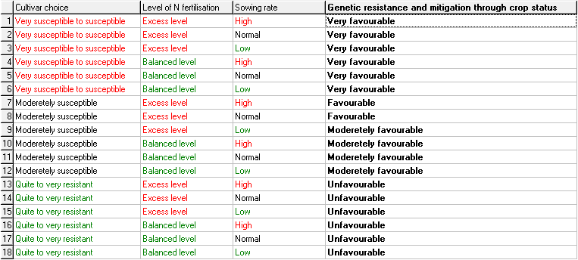
Resulting weights (calculated by DEXi):
83% 12% 5%

